***SS LAB***

***EXPERIMENT # 02***

***NAME : ADITYA PRATAP SINGH***

***ROLL NO. 16 EC01028***

***OBJECTIVE::***

To demonstrate the properties of different systems.

***MATLAB CODE::***

clc

clear all

close all

k=2;

for a=1:5

switch(a)

case 1

t=linspace(-3,3,1000);

%(i)

x=@(t) 3*t/4;

y=@(t,a) u(a*x(t));

linearity( y,t);

% input shift

x=@(t) 3*(t-k)/4;

y1=@(t) u(x(t));

y2=y1(t);

%output shift

y3=y(t-k,1);

if(y3==y2)

disp('Time Invarient');

else

disp('Time Varient');

end

disp('Causal');

count=0;

for i=-100:1:100

if(i<i)

count=count+1;

end;

end;

if(count>0)

disp('Has Memory');

else

disp('Memoryless');

end

case 2

%(ii)

t=linspace(1,7,100);

x=@(t) tri(t);

y=@(t,a) a*(x(t-5)-x(3-t));

linearity(y,t);

t=linspace(1,9,100);

% input shift

x=@(t) tri(t-k);

y1=@(t) x(t-5)-x(3-t);

y2=y1(t);

%output shift

y3=y(t-k,1);

if(y3==y2)

disp('Time Invarient');

else

disp('Time Varient');

end

count=0;

for i=-100:1:100

if((i-5)>i|(3-i)>i)

count=count+1;

end;

end;

count=0;

for i=-100:1:100

if((i-5)<i|(3-i)<i)

count=count+1;

end;

end;

if(count>0)

disp('Has Memory');

else

disp('Memoryless');

end

case 3

%(iii)

t=linspace(0,5,100);

x=@(t) tri(t);

y=@(t,a) a*x(t)./(a*x(t-1));

linearity(y,t);

% input shift

x=@(t) tri(t-k);

y1=@(t) x(t)./x(t-1);

y2=y1(t);

%output shift

y3=y(t-k,1);

if(y3==y2)

disp('Time Invarient');

else

disp('Time Varient');

end

disp('Causal');

disp('Has Memory');

case 4

%(iv)

t=linspace(-3,3,100);

x=@(t) tri(t);

y=@(t,a) a*x(t./2);

linearity(y,t);

% input shift

t=linspace(-1,6,100);

x=@(t) tri(t-k);

y1=@(t) x(t./2);

y2=y1(t);

%output shift

y3=y(t-k,1);

if(y3==y2)

disp('Time Invarient');

else

disp('Time Varient');

end

disp('Non-Causal');

disp('Has Memory');

case 5

%(v)

t=linspace(-3,5,100);

x=@(t) tri(t);

y=@(t,a) a*x(t).*cos(2*pi*t);

linearity(y,t);

% input shift

x=@(t) tri(t-k);

y1=@(t) x(t).*cos(2*4*t);

y2=y1(t);

%output shift

y3=y(t-k,1);

if(y3==y2)

disp('Time Invarient');

else

disp('Time Varient');

end

disp('Causal');

disp('Memoryless');

end

subplot(2,1,2);

plot(t,y2);

hold on;

plot(t,y3,'--');

grid;

title('if both graph coincides then system is time invariant otherwise time variant');

end

k=linspace(-5,10,1000);

a=5;

b=3;

K=8;

%QUESTION 2

%(i)

X1=@(T) u(T+0.5)-u(T-0.5);

%linearity

X2=@(T) tri(T);

y1=@(t) integral(X1,-inf,t);

y2=@(t) integral(X2,-inf,t);

X=@(T) a*(u(T+0.5)-u(T-0.5))+b*tri(T);

y=@(t) integral(X,-inf,t);

for i=1:1000

Y(i)=y(k(i));

Y1(i)=y1(k(i));

Y2(i)=y2(k(i));

end

if(Y==a*Y1+b*Y2)

disp('linear');

else

disp('Non-linear');

end

y=[a*Y1;b*Y2;Y];

figure();

subplot(2,1,1);

plot(k,y);

grid;

title('y1=blue line y2=red line y3=orange line and y1+y2=y3 gives linearity');

%Time Invariance Check

xt=@(T) u(T+0.5-K)-u(T-0.5-K);

yt=@(t) integral(xt,-inf,t);

Yt=@(t) integral(X,-inf,t-K);

for j=1:1000

yT(j)=yt(k(j));

YT(j)=Yt(k(j));

end

if(yT==YT)

disp('Time Invarient');

else

disp('Time Varient');

end

subplot(2,1,2);

plot(k,YT);

hold on

plot(k,yT);

grid;

title('if both graph coincides then system is time invariant otherwise time variant');

disp('Causal');

disp('Has Memory');

k=2;

for a=2:7

switch(a)

case 2

%(ii)

n=5;

t=linspace(-3,3,1000);

x=@(t) u(t+0.5)-u(t-0.5);

y=@(t,a) (a*x(t)).^n ;

linearity( y,t);

% input shift

x=@(t) u(t+0.5-k)-u(t-0.5-k);

y1=@(t) (x(t)).^n ;

y2=y1(t);

% output shift

y3=y(t-k,1);

if(y3==y2)

disp('Time Invarient');

else

disp('Time Varient');

end

disp('Causal');

disp('Memoryless');

case 3

%(iii)

t=linspace(-1,1,100);

x=@(t) u(t+0.5)-u(t-0.5);

y=@(t,a) exp(a*x(t));

linearity(y,t);

% input shift

t=linspace(0,3,100);

x=@(t) u(t+0.5-k)-u(t-0.5-k);

y1=@(t) exp(x(t));

y2=y1(t);

%output shift

y3=y(t-k,1);

if(y3==y2)

disp('Time Invarient');

else

disp('Time Varient');

end

disp('Causal');

disp('Memoryless');

case 4

%(iv)

t=linspace(-3,3,500);

x=@(t) u(t+0.5)-u(t-0.5);

y=@(t,a) diff(a*x(t));

linearity(y,t);

% input shift

t=linspace(-3,3,500);

x=@(t) u(t+0.5-k)-u(t-0.5-k);

y1=@(t) diff(x(t));

y2=y1(t);

%output shift

y3=y(t-k,1);

if(y3==y2)

disp('Time Invarient');

else

disp('Time Varient');

end

disp('Causal');

disp('Memoryless');

case 5

%(v)

t=linspace(-3,3,500);

x=@(t) u(t+0.5)-u(t-0.5);

y=@(t,a) diff(a*x(t-1));

linearity(y,t);

% input shift

t=linspace(-3,10,500);

x=@(t) u(t+0.5-k)-u(t-0.5-k);

y1=@(t) diff(x(t-1));

y2=y1(t);

%output shift

y3=y(t-k,1);

if(y3==y2)

disp('Time Invarient');

else

disp('Time Varient');

end

disp('Causal');

disp('Has Memory');

case 6

%(vi)

t=linspace(-3,3,500);

linearity(@f_1,t);

t=linspace(-3,3,500);

% INPUT SHIFT

x=@(t) u(t+0.5-k)-u(t-0.5-k);

y=@(t)diff(x(t));

s=y(t);

t(:,500)=[];

x=@(t) u(t+0.5-k)-u(t-0.5-k);

r=x(t);

y2=r.*s;

t=linspace(-3,3,500);

y3=f_1(t-k,1);

if(y3==y2)

disp('Time Invarient');

else

disp('Time Varient');

end

disp('Causal');

disp('Memoryless');

case 7

% (vii)

t=linspace(-3,3,500);

linearity(@f_2,t);

t=linspace(-3,3,500);

% INPUT SHIFT

x=@(t) u(t+0.5-k)-u(t-0.5-k);

y=@(t)diff(x(t-1));

s=y(t);

t(:,500)=[];

x=@(t) u(t+0.5-k)-u(t-0.5-k);

r=x(t);

y2=1*r.*s;

t=linspace(-3,3,500);

y3=f_2(t-k,1);

if(y3==y2)

disp('Time Invarient');

else

disp('Time Varient');

end

end

if(length(y2)==499)

t=linspace(-3,2.988,499);

end

disp('Causal');

disp('Has Memory');

subplot(2,1,2);

plot(t,y2);

hold on;

plot(t,y3,'--');

grid;

title('if both graph coincides then system is time invariant otherwise time variant');

end

***functions::***

***1.***

function [ z ] = linearity( y,t )

%UNTITLED10 Summary of this function goes here

% Detailed explanation goes here

n=5;

y1=y(t,3);

y2=y(t,5);

y3=y(t,8);

y=[y1;y2;y3];

if(length(y1)==499)

t(:,500)=[];

end

figure();

subplot(2,1,1);

plot(t,y);

grid;

title('y1=blue line y2=red line y3=orange line and y1+y2=y3 gives linearity');

if(y3==y1+y2)

disp('linear');

z=1;

else disp('non linear');

z=0;

end

end

***2.*** function [z ] =f_1( t,a )

%UNTITLED Summary of this function goes here

% Detailed explanation goes here

% t=linspace(-3,3,500);

x=@(t) u(t+0.5)-u(t-0.5);

y=@(t,a)diff(a*x(t));

s=y(t,a);

t(:,500)=[];

x=@(t) u(t+0.5)-u(t-0.5);

r=x(t);

z=a*r.*s;

end

***3.*** function [ z ] = f_2( t,a )

%UNTITLED2 Summary of this function goes here

% Detailed explanation goes here

x=@(t) u(t+0.5)-u(t-0.5);

y=@(t,a)diff(a*x(t-1));

s=y(t,a);

t(:,500)=[];

x=@(t) u(t+0.5)-u(t-0.5);

r=x(t);

z=a*r.*s;

end

***4.*** function [ y ] = tri(t )

%UNTITLED6 Summary of this function goes here

% Detailed explanation goes here

u1=(t+1)>=0;

r1=(t+1).*u1;

u2=t>=0;

r2=t.*u2;

u3=(t-1)>=0;

r3=(t-1).*u3;

y=r1-2*r2+r3 ;

end

***5.*** function [ y] = u( t )

%UNTITLED17 Summary of this function goes here

% Detailed explanation goes here

y=t>=0;

end

***RESULTS::***

***1. Non linear***

***Time Invariant***

***Causal***

***Memoryless***

***2. Linear***

***Time Variant***

***Non-Causal***

***Has Memory***

***3. Non linear***

***Time Variant***

***Causal***

***Has Memory***

***4. Linear***

***Time Variant***

***Non-Causal***

***Has Memory***

***5. Non linear***

***Time Variant***

***Causal***

***Memoryless***

***6. Non-linear***

***Time Variant***

***Causal***

***Has Memory***

***7. Non linear***

***Time Invariant***

***Causal***

***Memoryless***

***8. Non linear***

***Time Invariant***

***Causal***

***Memoryless***

***9. Linear***

***Time Invariant***

***Causal***

***Memoryless***

***10. Linear***

***Time Invariant***

***Causal***

***Has Memory***

***11. Non linear***

***Time Invariant***

***Causal***

***Memoryless***

***12. Non linear***

***Time Invariant***

***Causal***

***Has Memory***

***FIGURES::***

***Figure 1***

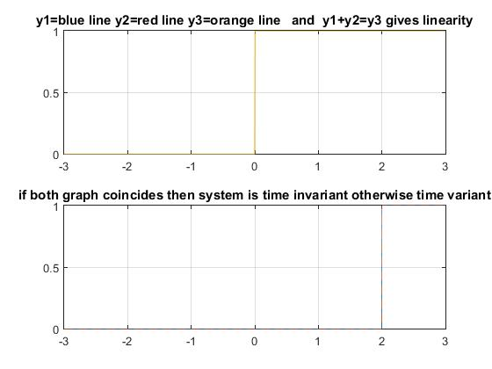

***Figure 2*** 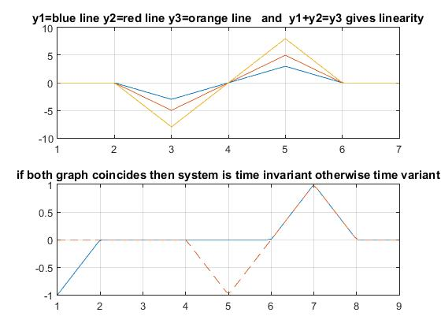

***Figure 3***

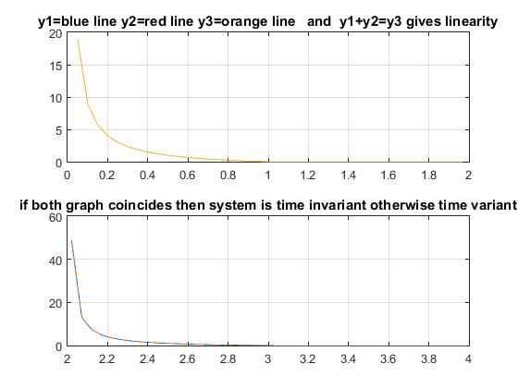

***Figure 4***

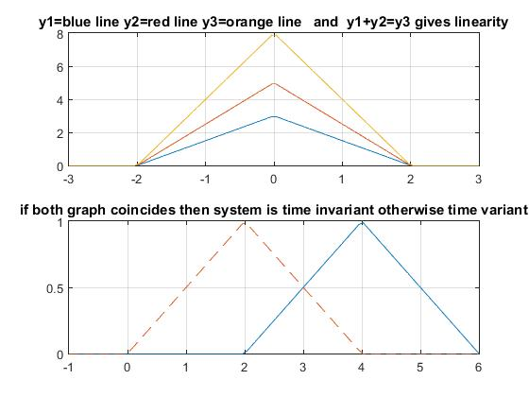

***Figure 5*** 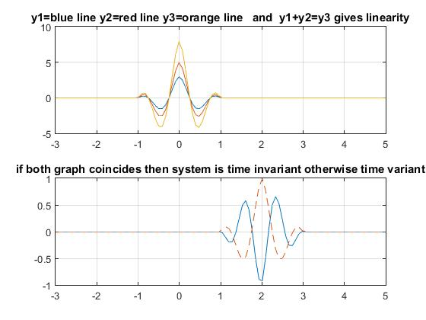

***Figure 6***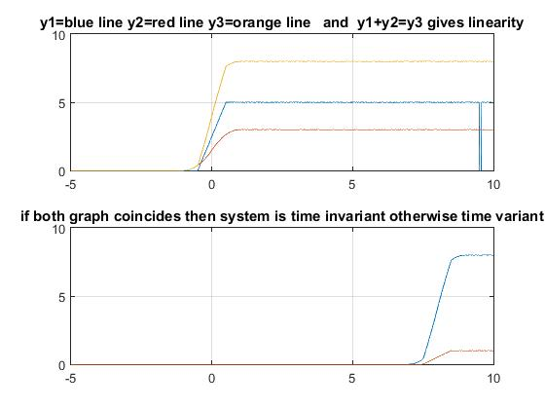

***Figure 7***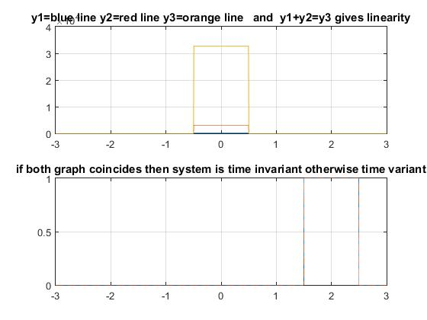

***Figure 8***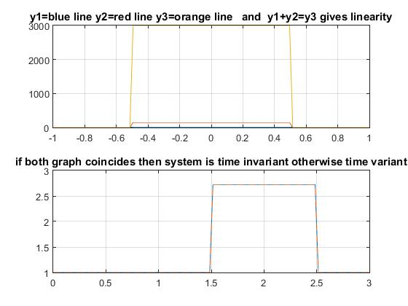

***Figure 9***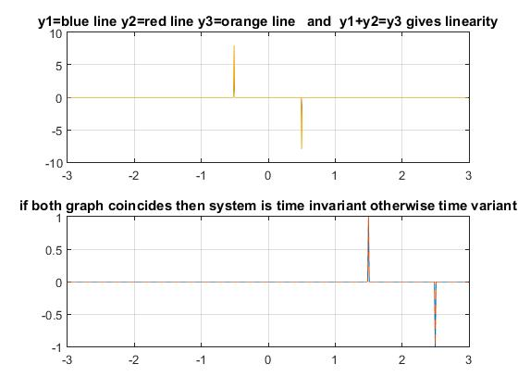

***Figure 10***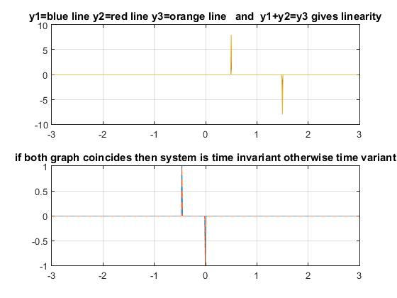

***Figure 11***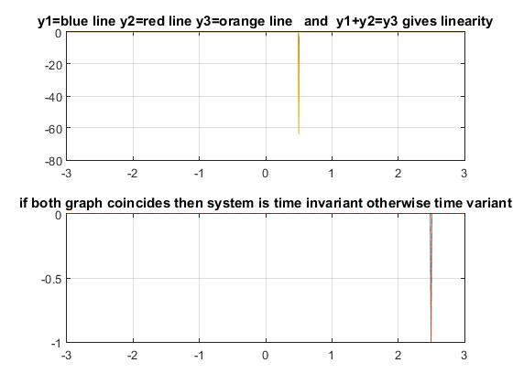

***Figure 12***

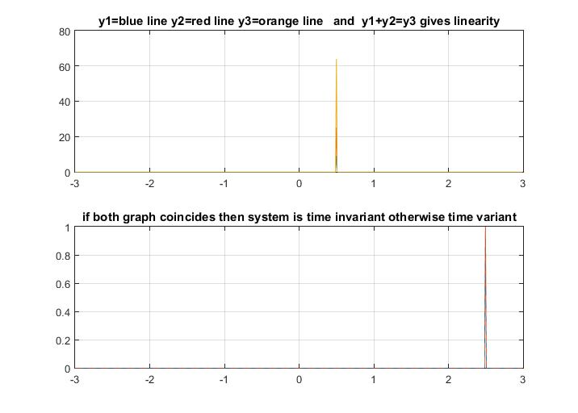

***OBSERVATIONS::***

After doing this experiment we come to know about various inbuilt functions in matlab like function handler,integration. We also learnt how to shift graph and check the system is linear or non-linear.